# Answers to Component 2 on Credit Task 3

Name: Lim Jia Lok

Student ID: 101212631

Selected Website & Link: Vincero Watches. <https://vincerowatches.com/>

## Enhance the a one-page corporate site template/Webpage (wireframe) which you have done in Pass Task 2:

## It should contain a minimum of 5 main parts namely: corporate banner/slider, main product/service highlight, product/service features, company profile, and footer.

## There must be a minimum of 10 individual boxes in your design.

## You need to provide additional wireframe for Mobile View (use col-xs-**).

**Desktop View Wireframe:**

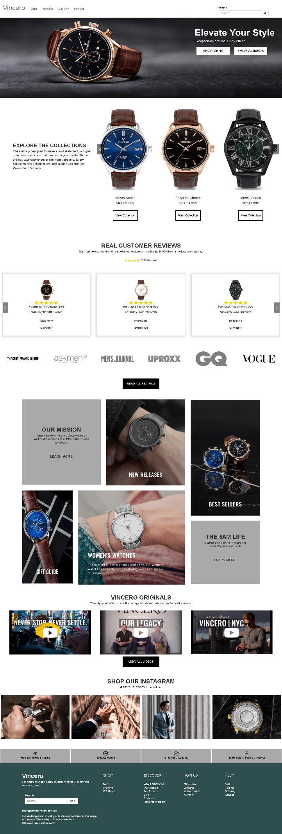

**Mobile View Wireframe:**



## Webpage Development Checklist & Evidences.

You are required to demonstrate your competency of website/webpage development using Bootstraps and AngularJS effectively by applying the concepts, topics and techniques learned in this unit.

|  |  |  |  |
| --- | --- | --- | --- |
| **ID** | **Criteria** | **Fulfilled (✓)** | **Evidence** |
| 1 | Effectively design and develop the webpage using Bootstraps’s Grid Layout | Yes | Used col-xs and col-md |
| 2 | Enable menu toggle in mobile view | Yes | Used menu toggle |
| 3 | Effectively applies at least two other Bootstraps components i.e. carousel / jumbotron / table / accordion / sliders/ glyphicons / modal box / etc… | Yes | Used jumbotron and carousel |
| 4 | Webpage is well rendered in both mobile and desktop view | Yes | In both view |
| 5 | Effective use of AngularJS’s common directive & filters | Yes | Used 6 directives |
| 6 | Effective use of AngularJS’s controller | Yes | Used to store arrays |
| 7 | Effective use of custom filter and/or custom directive | Yes | Used 6 directives |
| 8 | Appropriately store webpage content/data using array or JSON object and render to the view with proper data-binding techniques | Yes | Stored images as $scope.array and then ng repeat into the custom elements for directives |
| 9 | Webpage must pass HTML validation with no errors and warnings | Yes | NUChecker shows no warning |
| 10 | Webpage must comply with WCAG 1.0 (Level A) with no known problem – use Accessibility Check (achecker) | Yes | Passes according to achecker pdf provided |
| 11 | **[Optional]** Webpage must comply with WCAG 2.0 (Level AA with no known problem – use Accessibility Check (achecker) |  |  |
| 12 | Achieved 80% similarity from the selected website | Yes | Yes similar in layout and content |
| 13 | Appropriate section for acknowledgement and reference to the original website. | Yes | Yes it is in the website footer |